Determining the Molar Mass of a Volatile Liquid by the Dumas Method
Troy University Chemistry Faculty
Licensed under a Creative Commons Attribution-ShareAlike 4.0 International License.

Objectives
- Determine the density of the vapor of an unknown volatile liquid using the Dumas method.
- Calculate the molar mass of a volatile liquid using the ideal gas equation.

Introduction
The object of this lab is to determine the molar mass of a volatile liquid—that is, a liquid that vaporizes at a relatively low temperature. Molar mass, MM, is given by $\text{MM}=\frac{\text{mass}}{\text{moles}}$; the mass will be measured with a balance, and the moles will be determined using the ideal gas law: PV = nRT, so $n=\frac{PV}{RT}$.
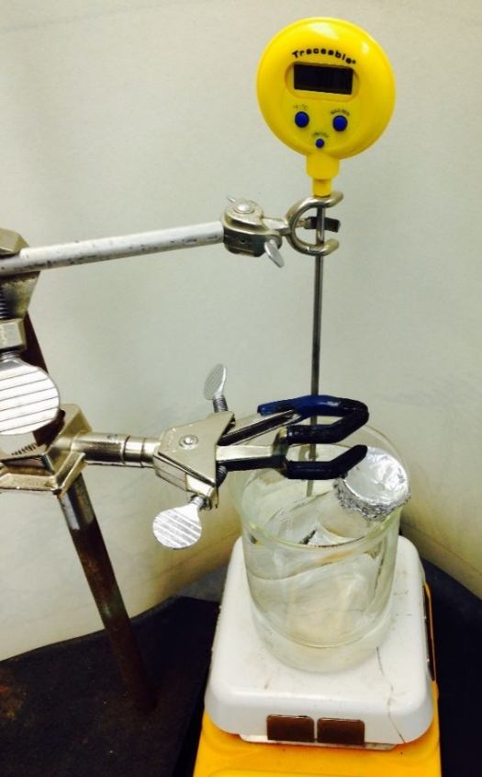
An Erlenmeyer flask will be filled with gas from the volatile liquid. To do this, a few milliliters of the volatile liquid are added to the flask, along with a boiling chip.
A liquid heated in a clean, smooth container can get superheated—its temperature can get higher than the normal boiling point. A superheated liquid tends to “bump”, which means it all boils at once, rather violently, sometimes sending liquid out of the container. Boiling chips (or stones) are used to “promote smooth boiling”. The jagged surfaces on these chips provide a place for boiling to start at.
The top of the flask is covered with aluminum foil, which has a tiny hole in it. The flask is placed in a water bath, which causes the unknown liquid to evaporate. When it has completely evaporated, the flask will be filled with just the unknown vapor.
As the liquid evaporates, gas is formed on its surface. This gas has a larger density than air does, so it stays on the bottom, with the air floating on top of it. As more liquid evaporates, more gas is formed, pushing the air out the pin hole. (Apparently, the air is pushed out of the hole faster than the air mixes with the unknown gas in the flask.) When the air has gone, the excess gas leaves through the pin hole.
The flask is then cooled under running water, which causes the vapor to condense back into the liquid phase. The presence of this liquid causes the flask to weigh more now than when it was empty.
Example: Here is an example to show how the molar mass of an unknown liquid would be calculated. Suppose a 125 mL Erlenmeyer flask containing a boiling chip and covered with some aluminum foil is weighed and found to have a mass of 143.122 g. To this flask is added 5 mL of an unknown liquid. The aluminum foil cap (which has a pin hole in it) is replaced and the flask is placed in a beaker of boiling water. The temperature of the water bath is found to be 92 °C; that is also the temperature of the gas in the flask. The pressure in the flask is the same as the pressure in the room (because of the pinhole); that pressure is measured with a barometer and found to be 75.7 cm of Hg (it’s an old barometer). When the unknown liquid has completely vaporized, the flask is removed from the water bath and cooled under a stream of tap water.
It isn’t easy to tell when the liquid has completely evaporated. The usual way is to watch for a ring of liquid around the boiling chip. When that ring seems to not be changing any more (or, better yet, completely disappears), the evaporation is assumed to be complete.
Another way to do it is to look at the jet of gas coming out of the pinhole in the aluminum foil. The gas jet makes the image behind it shimmer. (This gas is hotter than the surrounding air, so it has a different index of refraction, so light passing through it bends a bit, and appears to shimmer.) When the shimmer goes away, no more gas is coming out of the flask.
As soon as the flask is removed from the boiling water, you’ll think, “I didn’t heat it enough, because liquid is still present,” but that is just the gas starting to condense as the flask cools. After cooling a couple of minutes, the flask is dried and found to weigh 145.233 g (that includes the boiling chip and aluminum foil). So, the mass of liquid that filled the flask when vaporized is 145.233 g – 143.122 g = 2.111 g.
This liquid contains the same number of moles as when it was a gas in the flask, which is given by $n=\frac{PV}{RT}$. The volume of the gas is the volume that the 125 mL Erlenmeyer flask holds, which is actually a bit more than 125 mL. (You can see that the “125 mL” mark on it is below the top of the flask.) The empty Erlenmeyer flask is filled with water, which is then transferred to a 100 mL graduated cylinder in two portions: 76 mL and 68 mL, giving a total of 144 mL, so the volume of the flask (and gas) is 144 mL.
Let us use a value of R of 0.08206 L∙atm/(mol∙K). Convert the volume to L:
$?\text{L}=144 \text{mL}\left(\frac{1×{10}^{-3}\text{L}}{1 \text{mL}}\right)=0.144 \text{L}$ Eq (1)
Convert the pressure to atm:
75.7 cm of Hg is 757 mm Hg
$?\text{atm}=757 \text{mm Hg}\left(\frac{1 \text{atm}}{760 \text{mm Hg}}\right)=0.996 \text{atm}$ Eq (2)
Convert the temperature to kelvin: 92 °C is 365 K. (The temperature of the gas when it filled the flask was 92 °C, not room temperature.)
The number of moles of gas, then, is
$n=\frac{PV}{RT}=\frac{\left(0.996 \text{atm}\right)\left(0.144 \text{L}\right)}{\left(\frac{0.08206 \text{L}∙\text{atm}}{\text{mol}∙\text{K}}\right)365 \text{K}}=0.00479 \text{mol}$ Eq (3)
(Can you see why the result has only 3 significant figures?)
Now, the molar mass can be calculated:
$M\text{M}=\frac{\text{mass}}{\text{moles}}=\frac{\text{2.111 g}}{\text{0.00479 mol}}=441 \text{g/mol}$ Eq (4)
The density of a gas will also be calculated. Because the density of a gas is much less than the density of a liquid, the units used are g/L for the gas, rather than the more common g/mL. From the data above the density of the unknown liquid in the gaseous state is:
$\text{density}=\frac{\text{mass}}{\text{volume}}=\frac{\text{2.111 g}}{\text{0.14}\text{4}\text{ L}}=14.7 \text{g/L}$ Eq (5)

Chemical Alert
Volatile unknowns are flammable, toxic, and irritant. Do not use near an open flame. Prevent eye, skin, and clothing contact. Avoid inhaling vapor.

Procedure
- Prepare a hot-water bath by placing about 240 mL of tap water into a 400 mL beaker. Put the beaker on a hot plate, and set the hot plate to around 250 °C. Since the unknown volatile liquid has a boiling point lower than 100 °C, the water does not have to boil.
- Place a boiling stone into a dry 125 mL Erlenmeyer flask.
- Use a ruler and scissors to obtain a piece of aluminum foil that is about a 5 cm square.
- Place the foil over the mouth of the Erlenmeyer flask. Fold the sides down to make a tight seal. Later, when the flask is put in the water bath, the foil should not hang down into the water. To prevent that, squeeze the foil together so that it makes a little cap on the flask.
- Use a small pin (in a container at the front of the lab) to make a small hole in the center of the foil.
- Wipe the outside of the flask with a lab tissue to remove dust and fingerprints.
- Determine the mass of the dry flask, boiling stone, and foil cap to the nearest 0.001 g (some of the balances only record to the nearest 0.01 g; don’t use those balances for this lab). Record this mass in the data sheet.
- Carefully remove the foil cap, and add about 7 mL of an unknown liquid to the flask. Record the identification code of the unknown in the data sheet.
- Replace the foil cap securely. Touch the flask and cap as little as possible.
- Use a utility clamp to hold the flask submerged up to its neck in the water (as shown in the figure on the first page of this lab) . Suspend the flask at a slight angle so that both the liquid in the flask and the boiling stone are on one side of the flask bottom. (If necessary, tap or swirl the flask so that the boiling stone is submerged in the unknown liquid in the bottom of the flask.) Also, make certain that the water does not touch the foil cap. (On the other hand, you want as much of the flask in the water as possible, so that the gas in the flask will all be at the same temperature.)
- Suspend a thermometer in the water near the flask (the thermometer reading would not be accurate if the probe tip is touching the bottom of the beaker). Adjust the hot plate to maintain the water bath at 85-90 °C. (To speed up heating, the temperature setting of the hot plate can be increased to, 300 °C.)
- Allow the unknown liquid to vaporize completely. As the liquid vaporizes, its volume will decrease and bubbles form. Just before the liquid is totally vaporized, you will see a ring of liquid surrounding the boiling stone. The disappearance of the ring indicates that the vaporization is complete. Often, a tiny bit of water is present, and the ring won’t completely disappear. In that case, when the amount of liquid in the bottom of the flask stops changing, consider vaporization to be complete. It is easy to miss the complete vaporization of the unknown liquid so pay close attention to the inside of the flask. At the point of complete vaporization, record the water bath temperature in the data sheet.
- Immediately after the liquid completely vaporizes, remove the clamp-flask assembly from the water bath using the utility clamp as a holder. (As mentioned above, liquid will start to condense immediately; do not reheat.)
- Cool the flask and its contents to room temperature by holding the flask by the clamp under cold running water. Be quite careful that water does not collect under the aluminum foil.
- After the flask has cooled and the vapor condensed back into a liquid, remove the clamp from the flask.
- Thoroughly dry the outside of the flask and foil cap using a paper towel. Wipe the outside of the flask carefully to remove fingerprints.
- Using the same weighing scale as was used earlier, determine the mass of the flask, its contents, and the foil cap to the nearest 0.001 g. Record this mass in the data sheet.
- Discard the liquid remaining in the flask into the waste bucket labeled “Unknowns”. Transfer the boiling stone into the container labeled “Discarded Boiling Stones”.
- Thoroughly rinse the flask with tap water and fill it to the brim with tap water.
- Measure the volume of the flask by measuring the volume of water that is used to fully fill the flask to the brim. Note that this volume is not equal to the volume printed in the flask. To do this, carefully pour the water in portions from the filled flask into a 100-mL graduated cylinder. Add the volumes of the portions to obtain the total volume of the flask. Record this total volume in data sheet.
- Determine the pressure in the lab by reading the barometer in the lab. Record this pressure in the data sheet.

Calculations
- Calculate the mass of the unknown from the increase in mass of the flask.
- Convert the water bath temperature from °C to K.
- Convert the pressure from cm Hg to atm using equation (2).
- Convert the volume from mL to L using equation (1).
- Calculate the number of moles of unknown in the flask at the temperature of the hot water using (3).
- Calculate the molar mass using equation (4).
- Calculate the density in g/L using equation (5).
- Calculate the average molar mass.
- Show the instructor your results. The instructor will then provide you with the chemical formula of the unknown. From the formula, calculate the accepted molar mass of the unknown.
- Calculate the percent error using $\%=\frac{\left(experimental value-accepted value\right)}{accepted value} ×100$.
- Do a second determination by repeating steps 2-20 with the same flask. (Make sure the inside of the flask is completely dry!)
- Do a third determination by repeating steps 2-20.

Note
The instructor may deduct points if units are not included, and if the correct number of significant figures are not shown.

